Given head which is a reference node to a singly-linked list. The value of each node in the linked list is either 0 or 1. The linked list holds the binary representation of a number.
Return the decimal value of the number in the linked list.

Example 1:
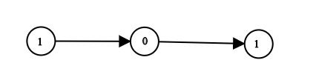
Input: head = [1,0,1]
Output: 5
Explanation: (101) in base 2 = (5) in base 10
Example 2:
Input: head = [0]
Output: 0
Example 3:
Input: head = [1]
Output: 1
Example 4:
Input: head = [1,0,0,1,0,0,1,1,1,0,0,0,0,0,0]
Output: 18880
Example 5:
Input: head = [0,0]
Output: 0

Constraints:
- The Linked List is not empty.
- Number of nodes will not exceed 30.
- Each node's value is either 0 or 1.

